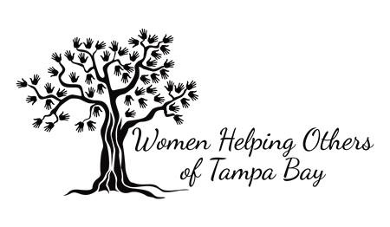
Youth Volunteer Parental/Guardian Consent Form

Dear Parents/Guardians,

Your son/daughter is interested in volunteering with Women Helping Others of Tampa Bay, Inc.’s monthly program ”W.H.O.’s Feeding the Less Fortunate”. Please read and sign this form. By signing this letter you are stating that you will fully support your son/daughter in their journey to serve their community.

The W.H.O.’s Feeding the Less Fortunate program is monthly, and it consists of providing and serving the less fortunate (homeless) in the area via food, clothing and toiletries. It is held at Borrell Park, 808 E 26th Ave., Tampa, FL 33603.

PARENTAL PERMISSION
For those under 18 years of age

I give permission as parent or legal guardian of: ______________________________________
(Name-please print)

Signature_________________________________________________ Date: _______/_____/________

Relationship: _____________________________________________

Home Phone: ___________________________ Work Phone: ________________________

